

Faculty of Engineering & Technology

Electrical & Computer Engineering Department

ENCS 3320 - Computer Networks

Report1 – Project 1

“**Socket Programming”**

Prepared by:

Tala Dweikat 1191590

Rania Shahwan 1190585

Mazen Batrawi 1190102

Instructor: Dr. Muhammad Helal

Section: 2   
Date: 30/4/2022

Abstract

This project consists of two parts. The first part is to run some commands on the terminal; ping a device in the same network, ping YouTube website, tracert and nslookup it. The second part is to implement a simple but a complete web server in python that is listening on port 900. Both html and css are used for the design of our website.

Table of Contents

Part1: Running Commands 4

1- Ping a device in the same network. 4

2- Ping www.youtube.com 5

3- Traceroute www.youtube.com 6

4- nslookup www.youtube.com 7

Part2: Creating a web server 8

1- First page English version website. 8

2- Second page English version website 11

3- First and second pages of Arabic version website 14

5- Request ends with .html 18

6- Request ends with .css 19

7- jpg request 20

8- png request 21

9- 307 Temporary redirct 22

10- Error page 23

11- Testing from another device 25

Appendix 26

Table of Figures

Figure 1: Ping a host 4

Figure 2: Ping a website (yoututbe) 5

Figure 3: Traceroute command 6

Figure 4: Nslookup Command 7

Figure 5: Page 1 English version request 8

Figure 6: Page 1 English version website 8

Figure 7: Main_en.html code 9

Figure 8: Design.css code 10

Figure 9: Page 2 English version request 11

Figure 10: Page 2 English version website 11

Figure 11: Main2_en.html code 12

Figure 12: Design2.css code 13

Figure 13: Page 1 Arabic version request 14

Figure 14: Page 1 Arabic version website 14

Figure 15: Main_ar.html code 15

Figure 16: Page 2 Arabic version website 16

Figure 17: Main2_ar.html code 16

Figure 18: Design2_ar.css code 17

Figure 19: A .html request 18

Figure 20: Response of a .html request 18

Figure 21: A .css request 19

Figure 22: Response of a .css request 19

Figure 23: A .jpg request 20

Figure 24: Response of a .jpg request 20

Figure 25: A .png request 21

Figure 26: Response of a .png request 21

Figure 27: Requests of a 307 temporary redirct to CNN website 22

Figure 28: CNN Redirect 22

Figure 29: Code of error page 23

Figure 30: Error page 24

Figure 31: Testing project from a phone 25

Part1: Running Commands

1- Ping a device in the same network.

Ping is a command that can be used to troubleshoot network issues, such as network connectivity. The Ping utility uses the echo request, and echo reply messages within the Internet Control Message Protocol (ICMP). It sends 4 requests by default in Windows, it also contains information such as the bytes sent and received, time to live (TTL), how long the response took to receive, and statistics about packet loss and round trip times. Figure below shows pinging a host with received response from 192.168.1.65 with some information, different delays but an average round trip times of 125ms.

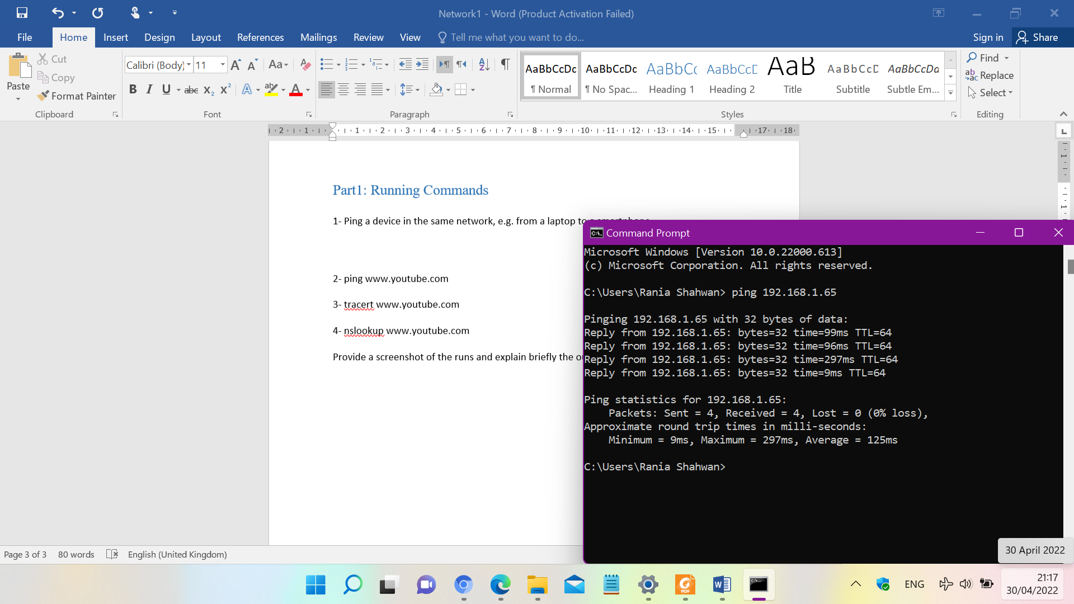

Figure : Ping a host

## 2- Ping [www.youtube.com](http://www.youtube.com)

Pinging a website is actually pinging the domain name and not its’ IP address. Because also name resolution issues related to DNS is tested, as the IP address is not memorized. Here a successful reply from [www.youtube.com](http://www.youtube.com) is received, so the device is connected to the internet, and all hardware such as cables, the network card, the router and the modem are all working correctly, including the internet service provider. Four packets response were reived from 172.217.16.142 with their TTL, 75ms delay so also an average of 75ms.

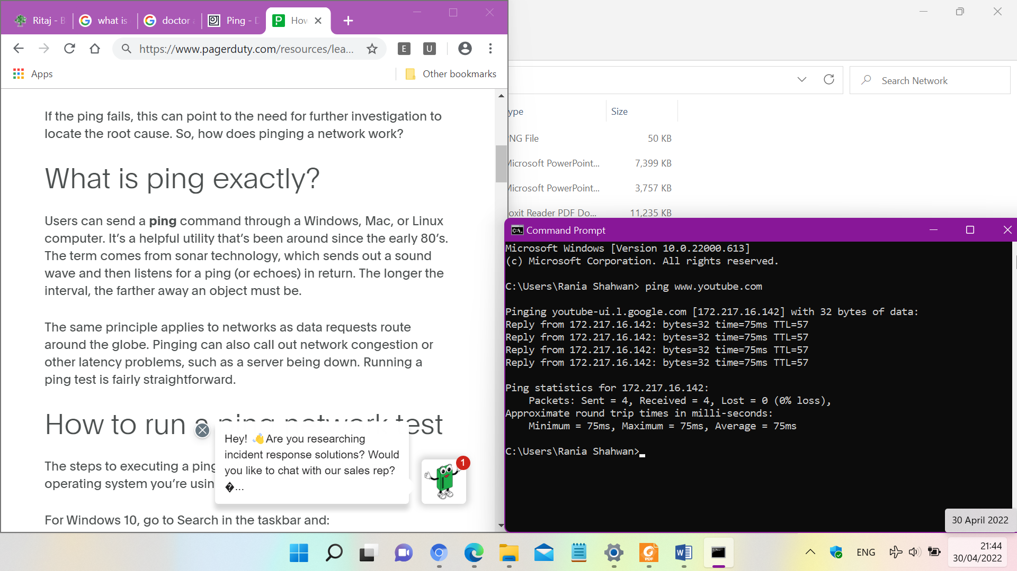

Figure : Ping a website (yoututbe)

## 3- Traceroute [www.youtube.com](http://www.youtube.com)

Traceroute command (tracert) is a utility designed can be used for troubleshooting of connection issue, displays the time it takes for a packet of information to travel between a local device and a destination of IP address or domain. After performing this command for [www.youtube.com](http://www.youtube.com), the results displayed are the hops that data packets take along their path to destination desired. When the measurements are stars (*) in request timed out and indicates that the router at that hop doesn't respond to the traceroute requests.

The response structure is Hop   RTT1     RTT2    RTT3    Name [IP Address].

Where hop number is the path from sender to receiver, and round trip time (RTT) time it takes for a packet to get to a hop and back, in milliseconds (ms).

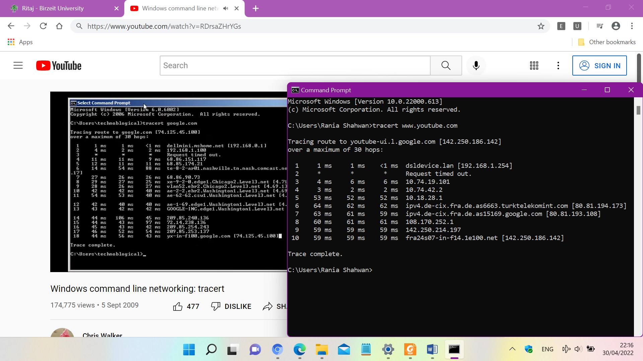

Figure : Traceroute command

## 4- nslookup [www.youtube.com](http://www.youtube.com)

Command of nslookup followed by the domain name displays a record IP address of the domain. It queries to domain name and address servers and gets the details. This can be shown in figure below.

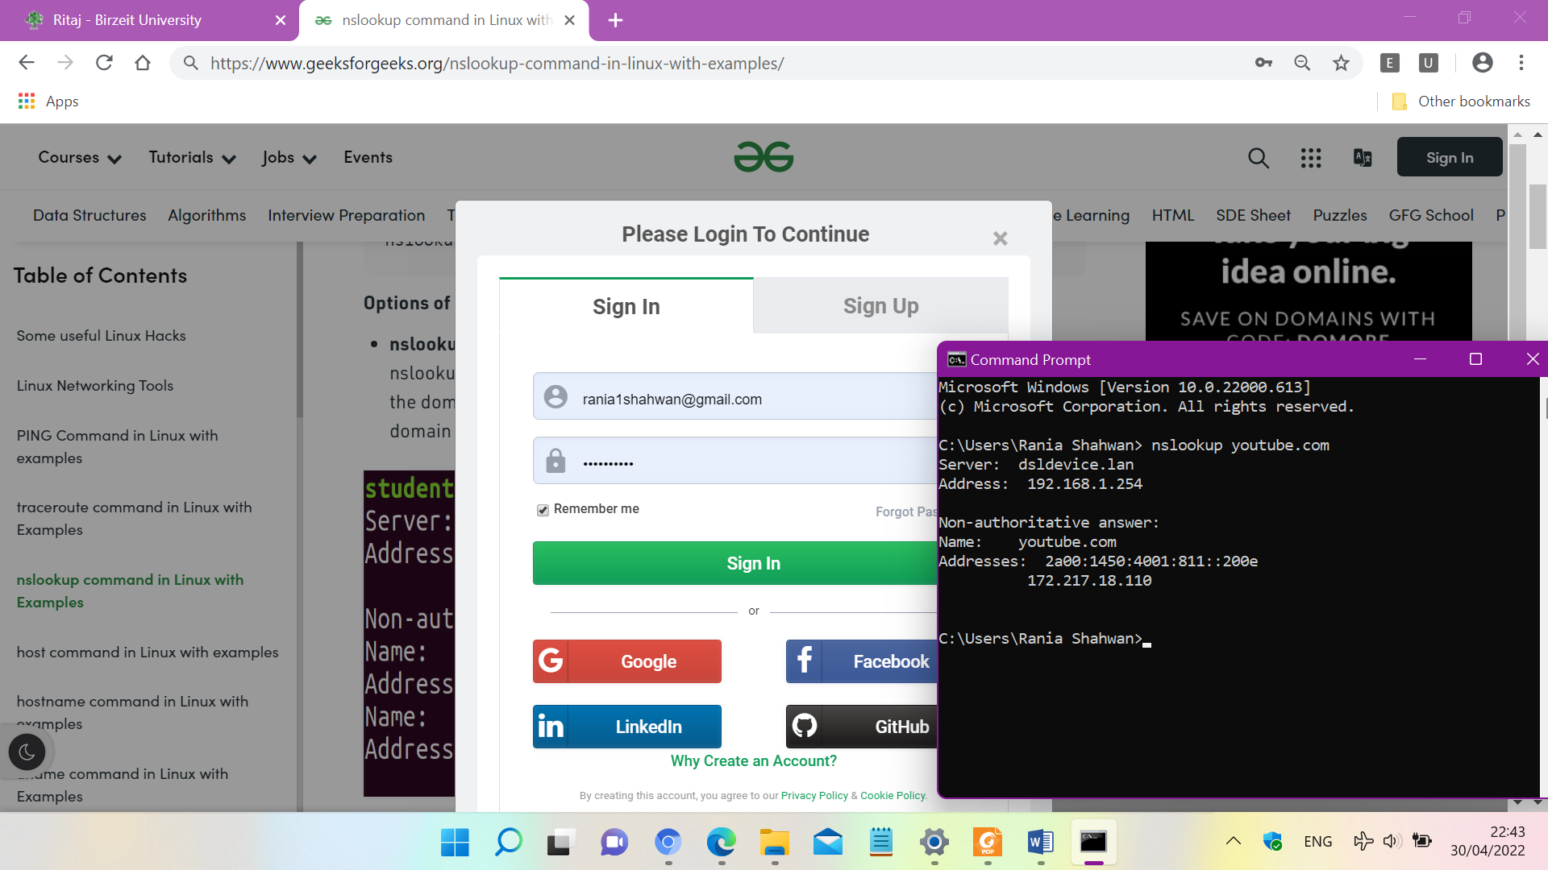

Figure : Nslookup Command

Part2: Creating a webserver

In this part of the project, the socket programming in Python language was applied to carry out a simple web server that server eight different requests specified and shows the HTTP requests on the terminal window.

* First Page English Version Website
* 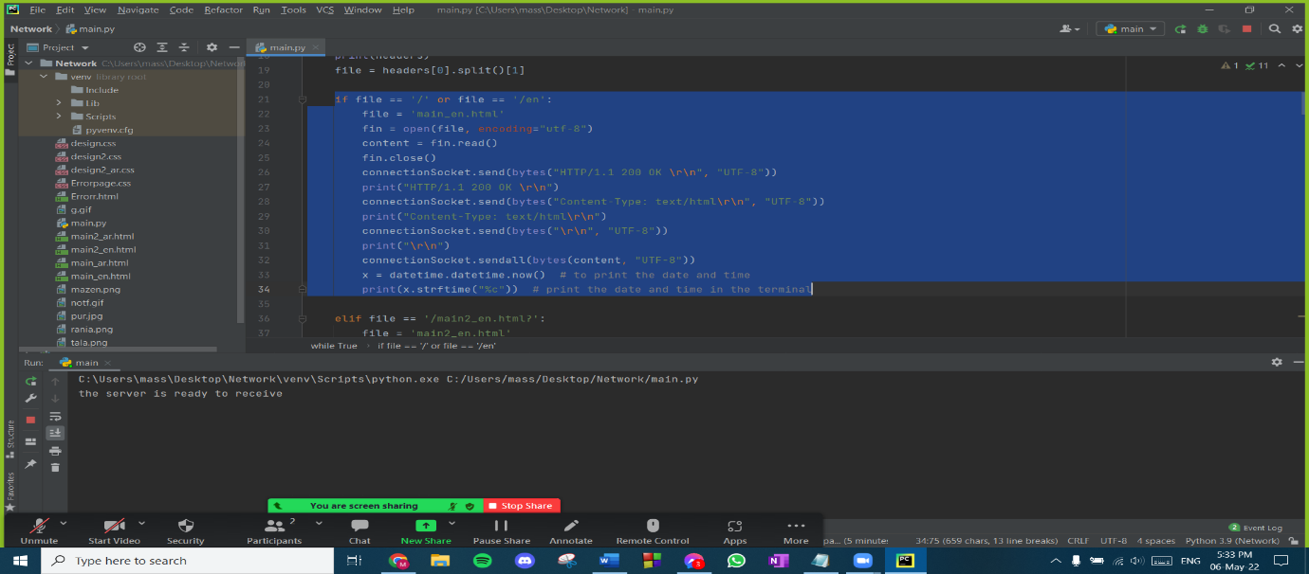If the request is sent with /, en, then the server sends main_en.html file with content-type: text/html.

Figure 5: Page 1 English Version request

* 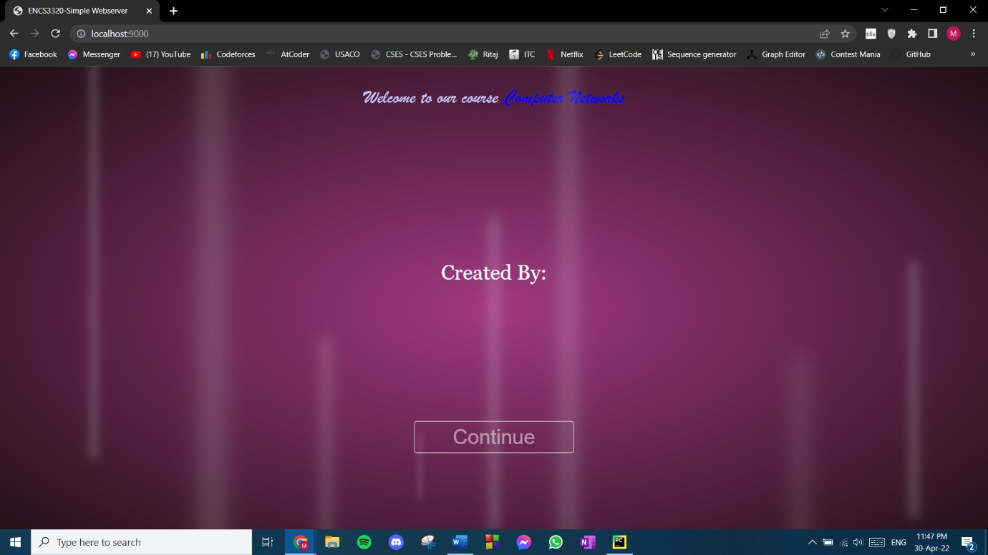The following website appears, it was styled using html and css

Figure 6: Page 1 English Version website

* + HTML section for the first page of English version website

For the HTML code, “Welcome to our course computer networks” and “created by our team names and IDs, stay tuned” were printed on the first page of our website. And a “continue” button was added with a link to the second page of the website. This is the first page of the English version of the website. All these texts were styled in the CSS code. A link for the CSS code was added to the HTML code shown above.

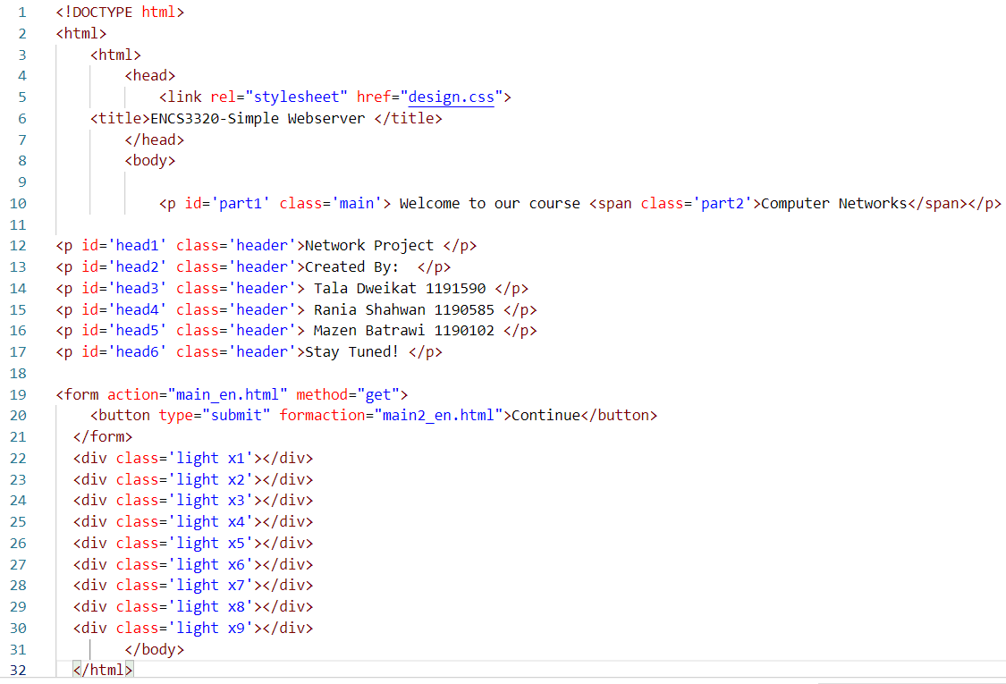

Figure 7: Main_en.html code

* + CSS section for the first page of English version website

The CSS code shown below is the one which styles the website and texts. For the background image, a GIF image was chosen with the purple colour, as shown in figure 6 above. “Welcome to our course” was written in white, “computer networks” was written in blue as required. A timer was set for each name and ID. When one of the names and numbers disappear the other appears after 4 seconds. When we press the “continue” button that was styled in white, we will get to the second page of the English version website.

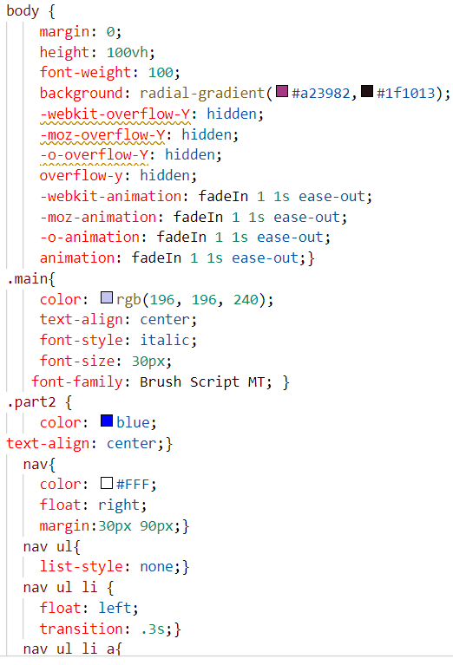 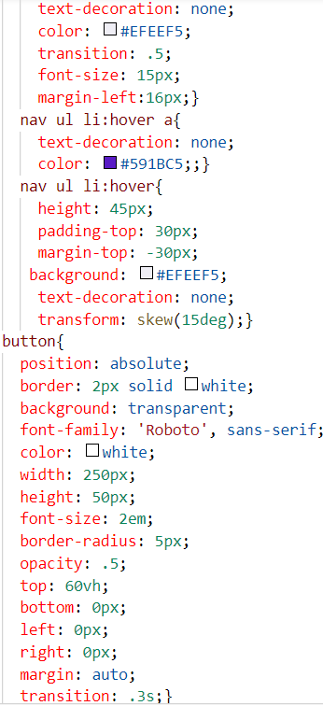 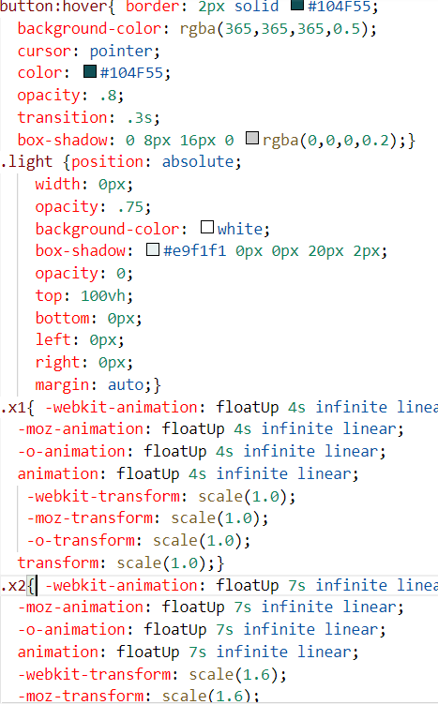

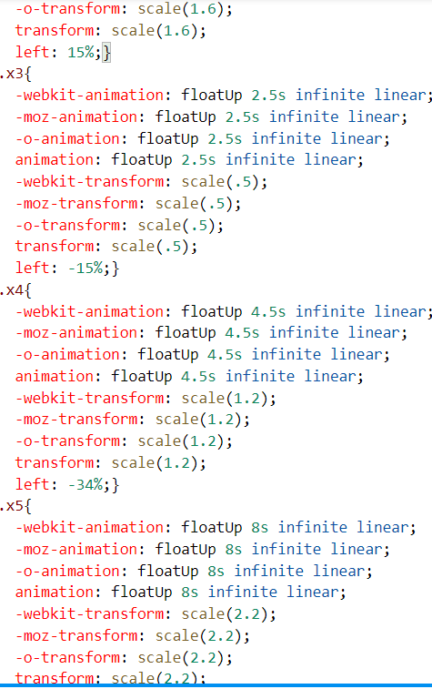 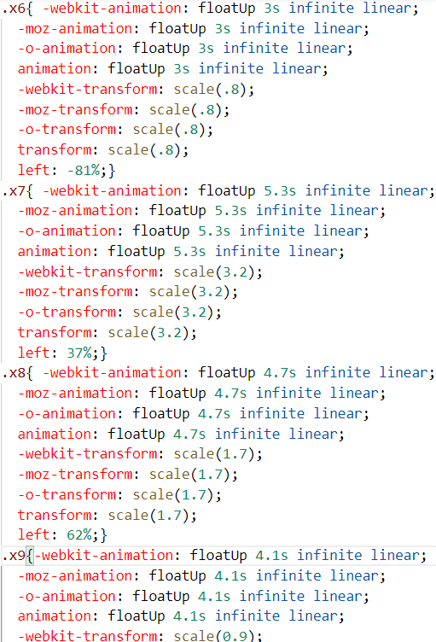 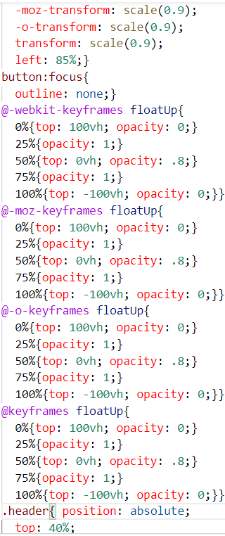

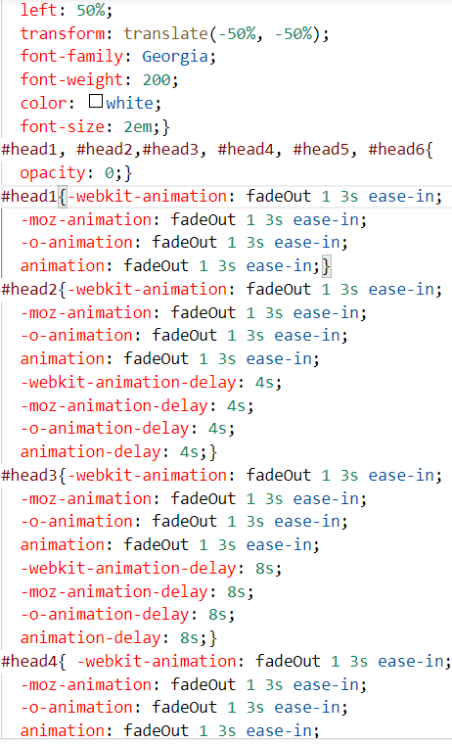 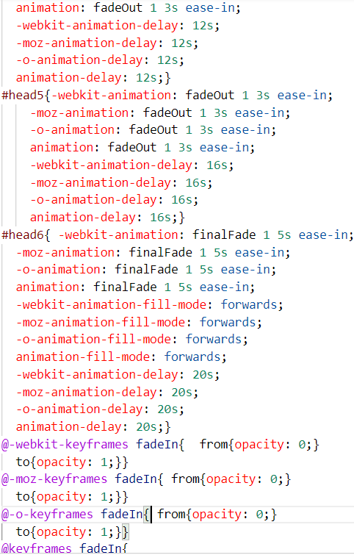 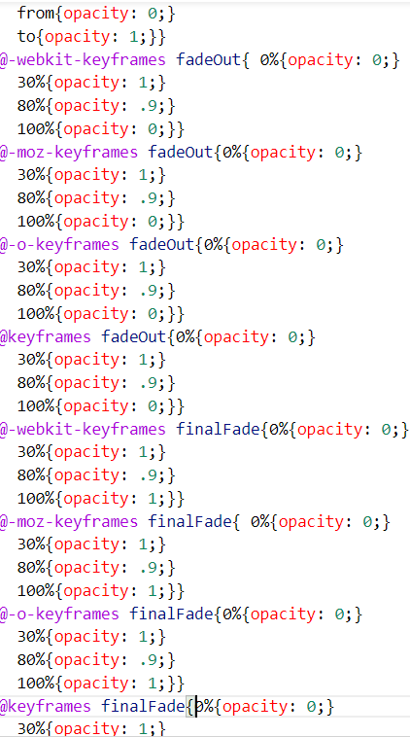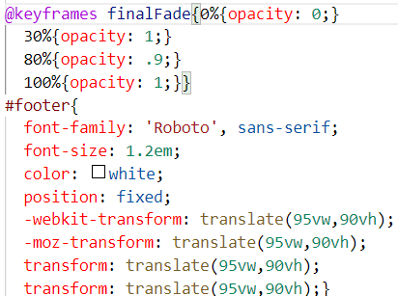

Figure 8: Design.css code

* Second page of English version
* 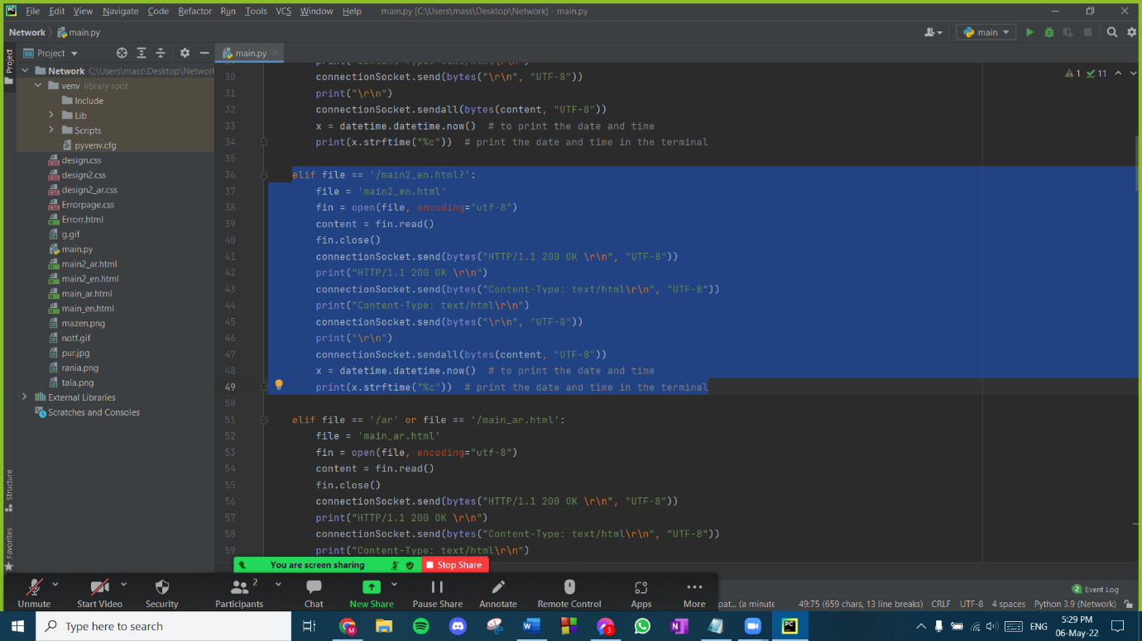When the ‘continue’ button on the first page on English version is pressed. Then a link to the second page will be open, and the server sends main2_en.html file with content-type: text/html.

Figure 9: Page 2 English Version request

* 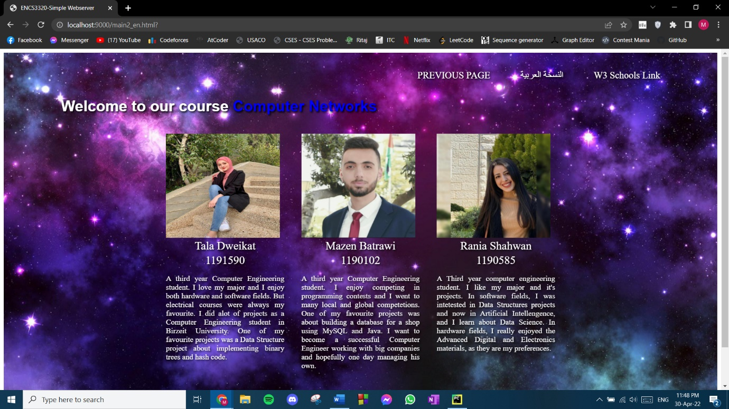The following website appears, it was styled using html and CSS

Figure 10: Page 2 English version website

* + HTML section for the second page of English version website

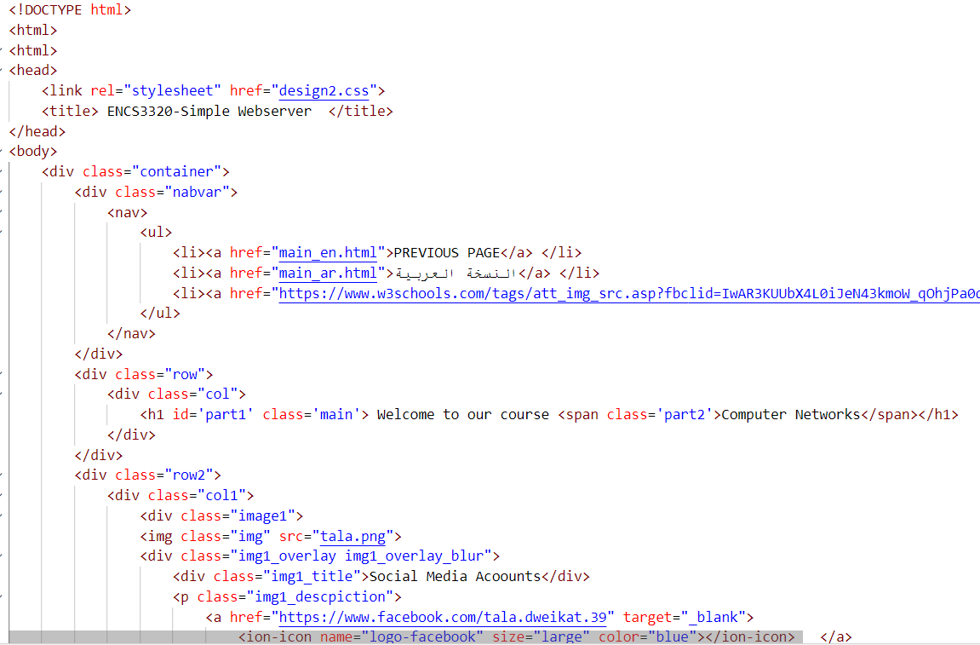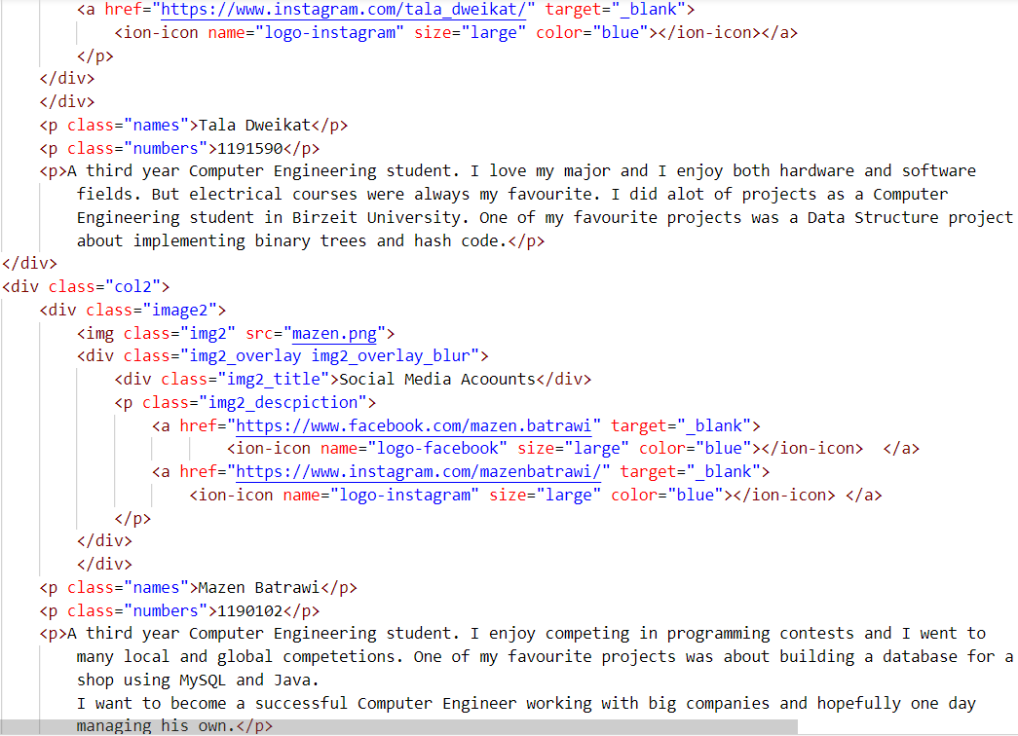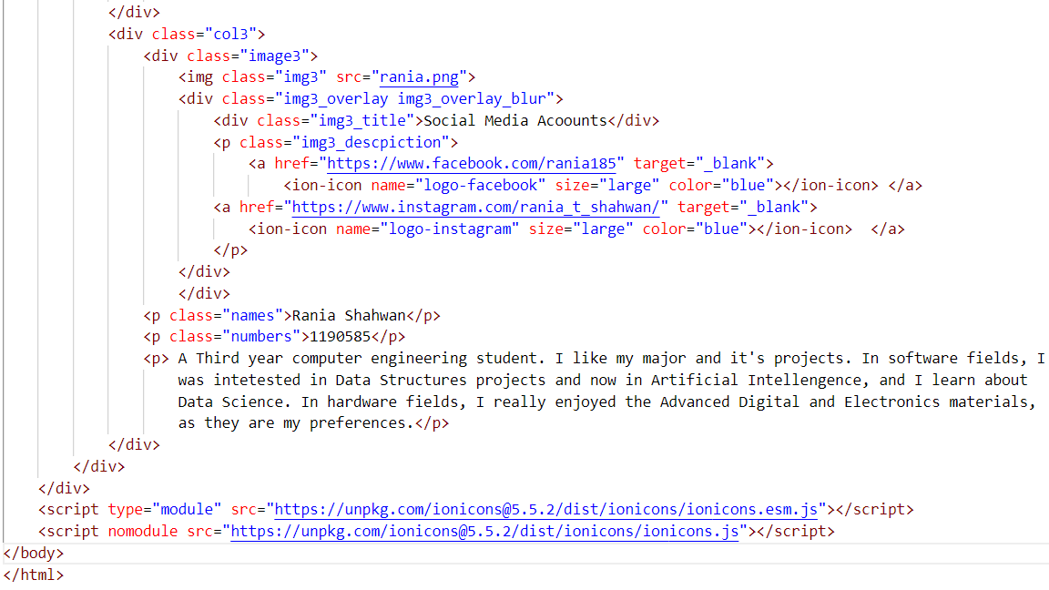After pressing the ‘continue’ button, the second page of the English version website appears. This page consists of three sections which have the names, information and pictures (with .png extension) of group members, each section has information about a single member of the team. Links of social media accounts will be associated with a hover propriety on the pictures of the group members. ‘Welcome to our course computer networks’ was written on the page. On the top of the page, some links were associated; a link to the previous page (leads to the first page on English version website), a link to the Arabic version website (leads to the first page of Arabic version website), and a link to WS schools website. A background image with the .jpg extension was chosen.

Figure 11: main2_en.html code

* + CSS section for the second page of English version website

This section is for styling the website. All information about the group members are separated in three boxes, box for each. They were written in white with pictures of the group members. When you get the mouse over the three pictures of the group members, the pictures with be hovered and the social media accounts for each of them will appear on the picture. When you press on the Facebook logo, a link will be associated with it and it will open a new website with the page of Facebook account, the same will happen when pressing on the Instagram logo. ‘Welcome to our course’ was written in white, ‘computer networks’ was written in blue as required. On the top of the page, some links were associated; when pressing on them, a new website will be open with the link associated in the HTML section. They were written in white.

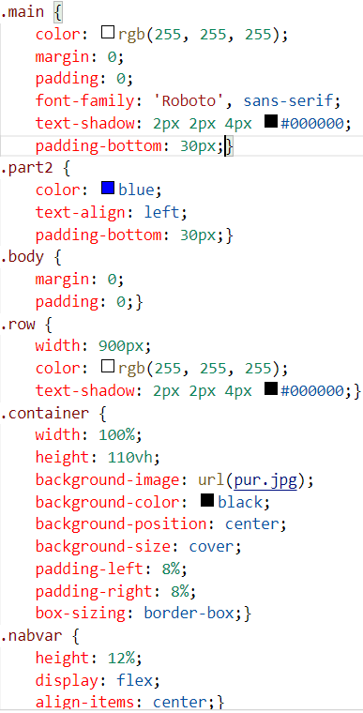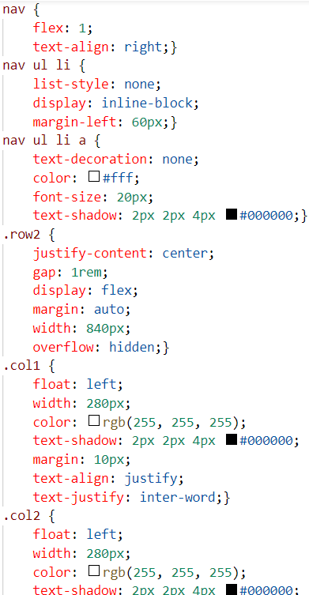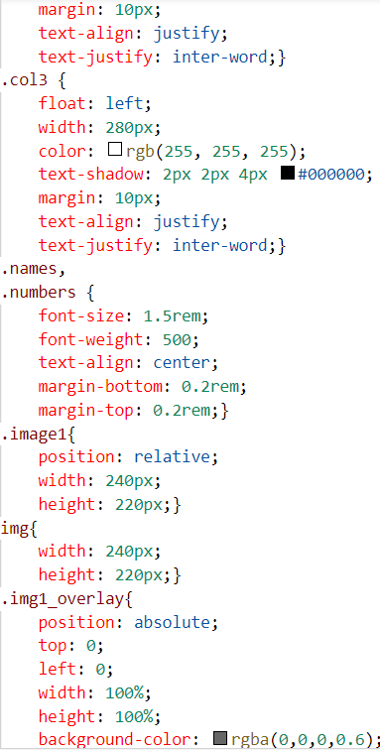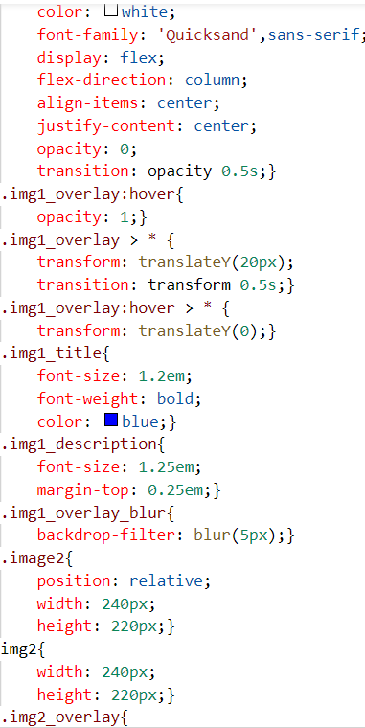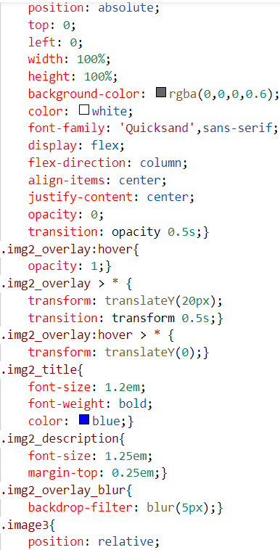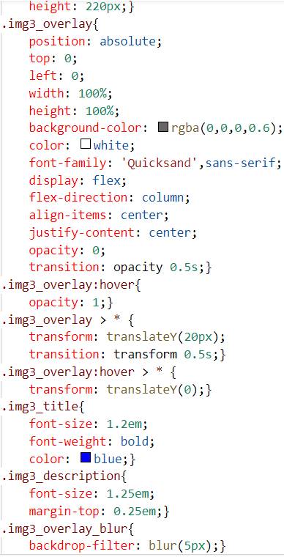

Figure 12: design2.css code

* First page of Arabic version
* 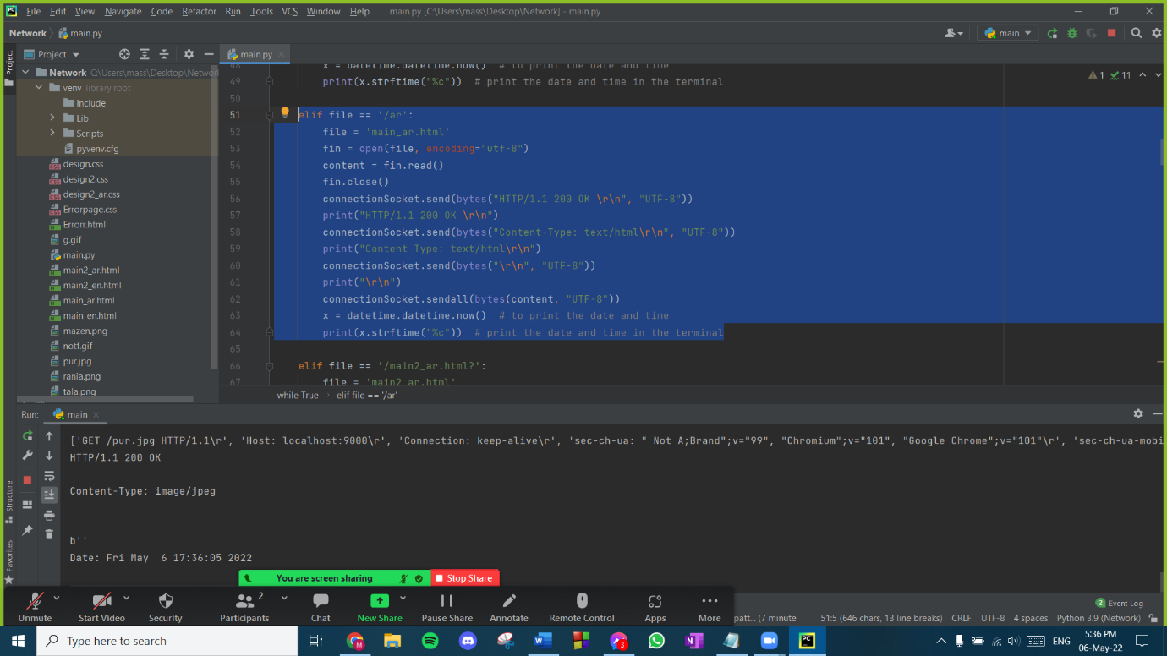If the request is sent with /ar then the server response with main_ar.html which is an Arabic version of main_en.html

Figure 13: Page 1 Arabic version request

* The following website will appear, it was styled with HTML and CSS:

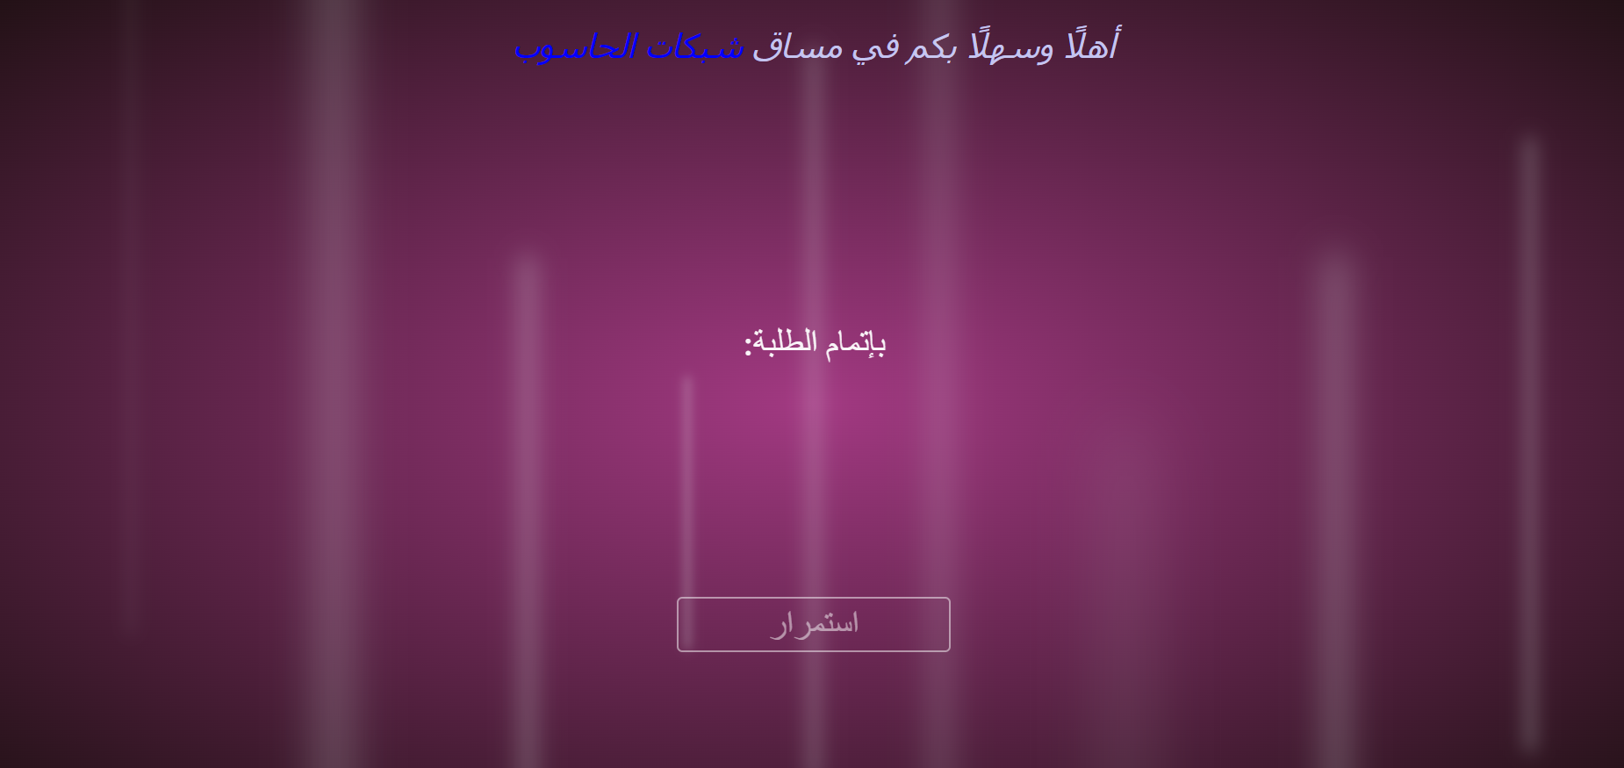

Figure 14: first page of Arabic version website

* + HTML section for the first page of Arabic version website

For the HTML code, “اهلا بكم في مساق شبكات الحاسوب” and “باتمام الطلبة: مع اسماء والارقام الجامعية لاعضاء الفريق” were printed on the first page of our website. And “استمرار” button was added with a link to the second page of the website. This is the first page of the Arabic version of the website. All these texts were styled in the CSS code. A link for the CSS code was added to the HTML code shown above.

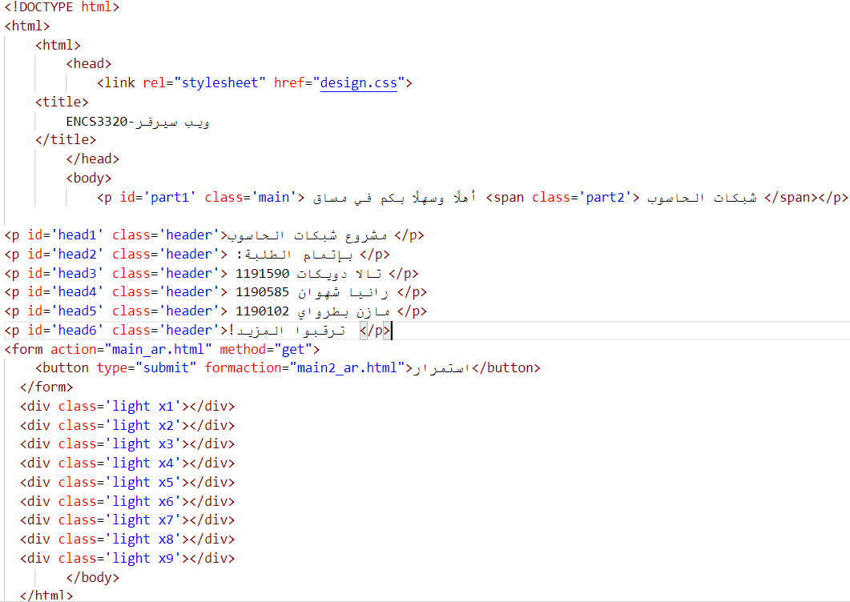

Figure 15: main_ar.html code

* + 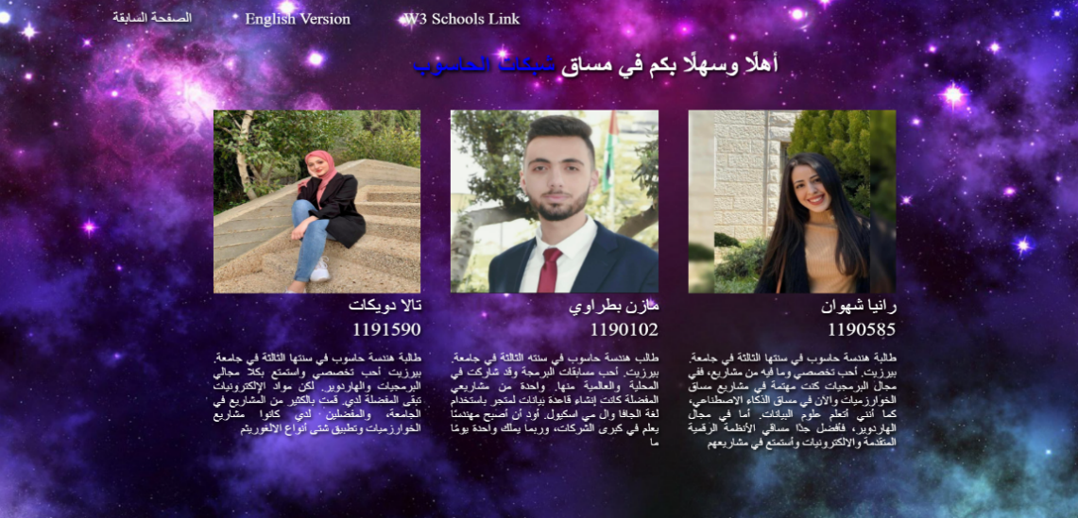HTML section for the second page of Arabic version website

Figure 16: second page of Arabic version website

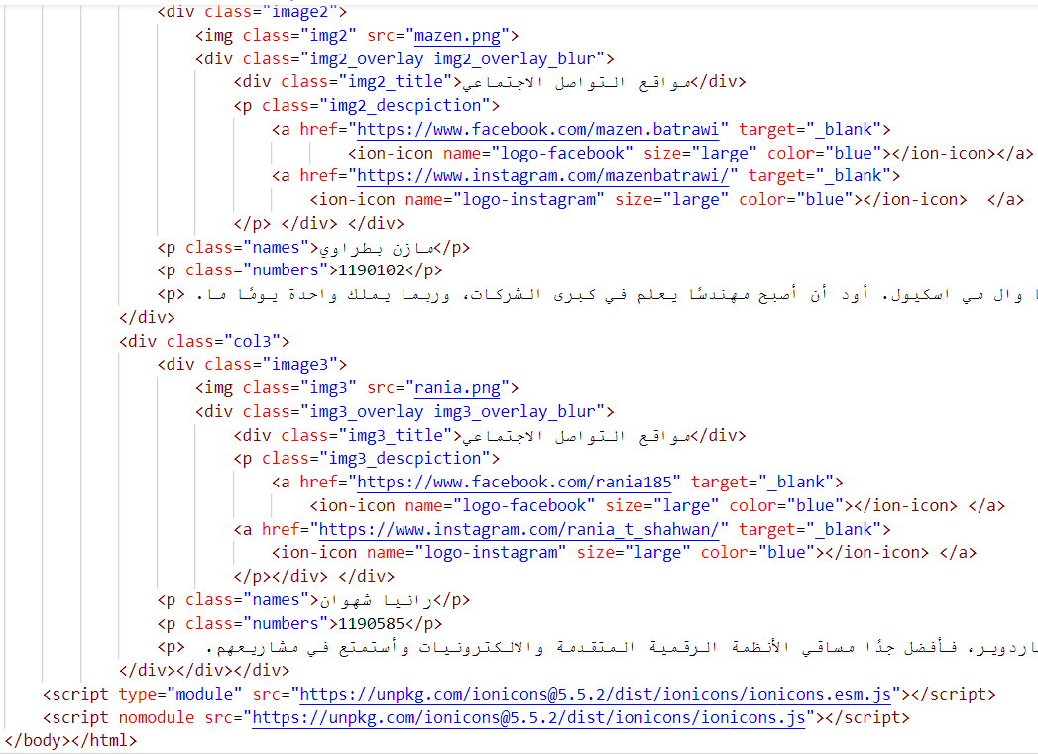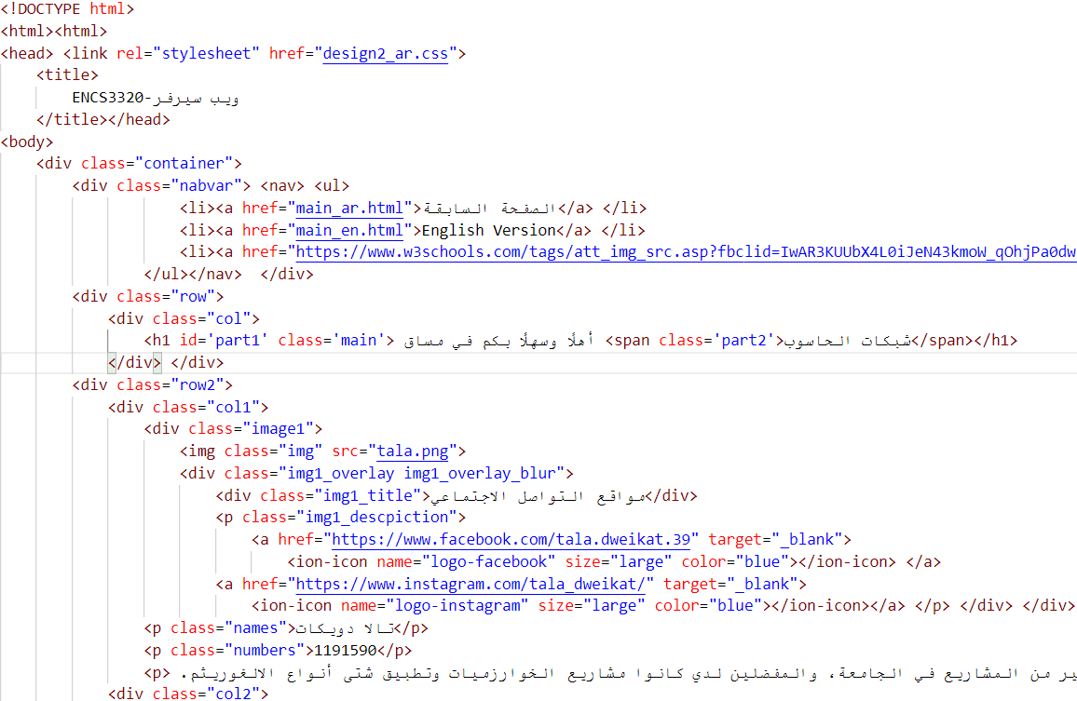After pressing ‘استمرار’ button, the second page of the Arabic version website appears. This page consists of three sections which have the names, information and pictures (with .png extension) of group members all in Arabic, each section has information about a single member of the team. Links of social media accounts will be associated with a hover propriety on the pictures of the group members. ‘اهلا بكم في مساق شبكات الحاسوب’ was written on the page. On the top of the page, some links were associated; a link to the previous page (leads to the first page on English version website), a link to the English version website (leads to the first page of English version website), and a link to WS schools website. A background image with the .jpg extension was chosen.

Figure 17: main2_ar.html code

* + CSS section for the first and second page of Arabic version website

The CSS code shown below is the one which styles the website and texts. For the background image, a GIF image was chosen with the purple colour, as shown in figure 13 above. “اهلا بكم في مساق” was written in white, “شبكات الحاسوب” was written in blue as required. A timer was set for each name and ID which were written in Arabic. When one of the names and numbers disappear the other appears after 4 seconds. When we press the “استمرار” button that was styled in white, we will get to the second page of the Arabic version website. In the second page: all information about the group members are separated in three boxes, box for each. They were written in white and arabic with pictures of the group members. When you get the mouse over the three pictures of the group members, the pictures with be hovered and “مواقع التواصل الاجتماعي” for each of them will appear on the picture. When you press on the Facebook logo, a link will be associated with it and it will open a new website with the page of Facebook account, the same will happen when pressing on the Instagram logo. ‘اهلا بكم في مساق’ was written in white, ‘شبكات الحاسوب’ was written in blue as required. On the top of the page, some links were associated; when pressing on them, a new website will be open with the link associated in the HTML section. They were written in white.

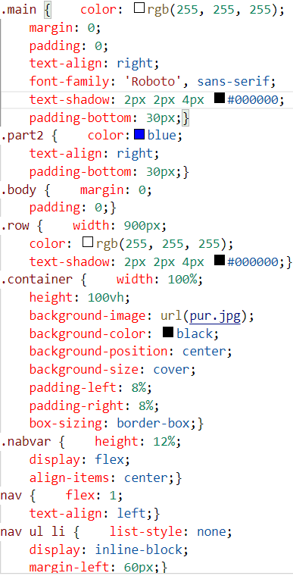 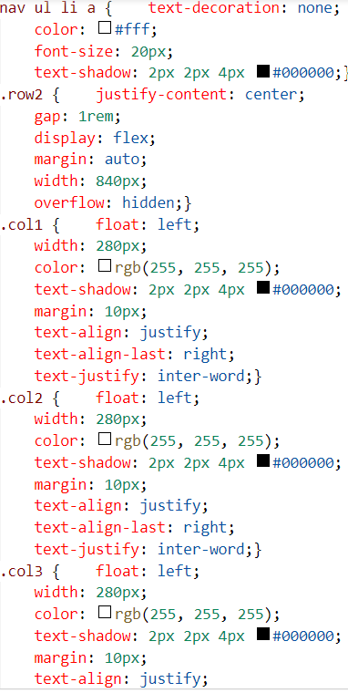 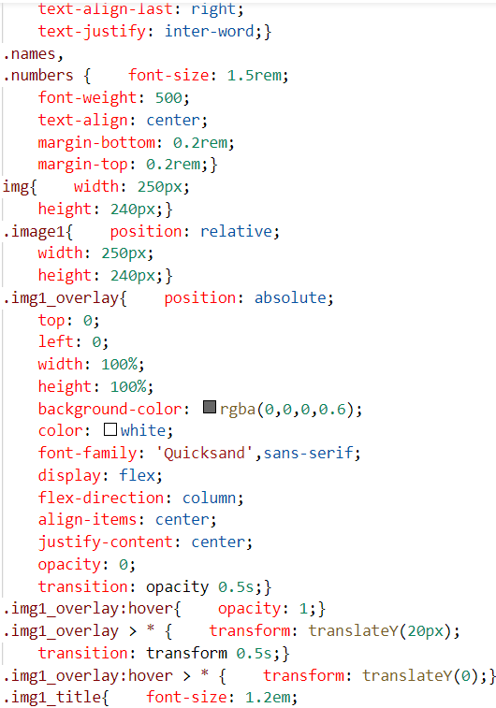

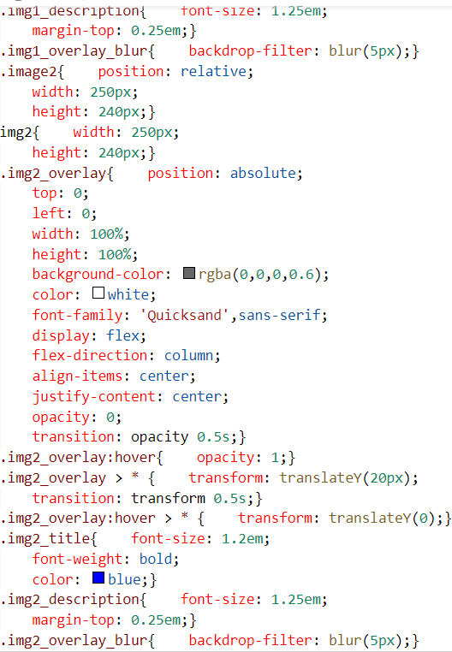 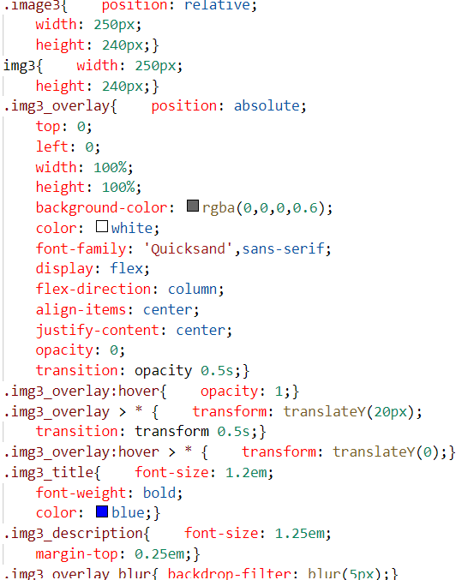

Figure 18: Design2_ar.css code

* Request ends with **.html:**

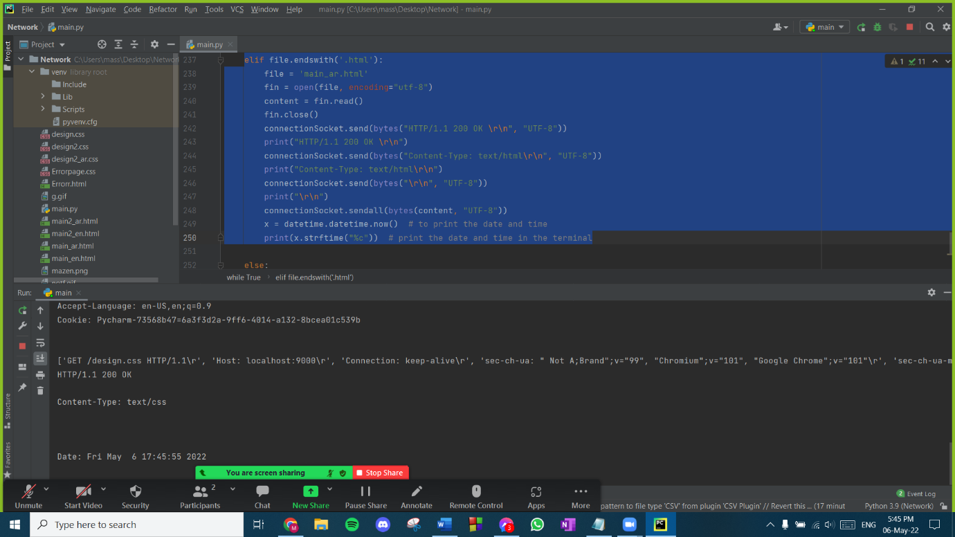

*Figure 19: A .html request*

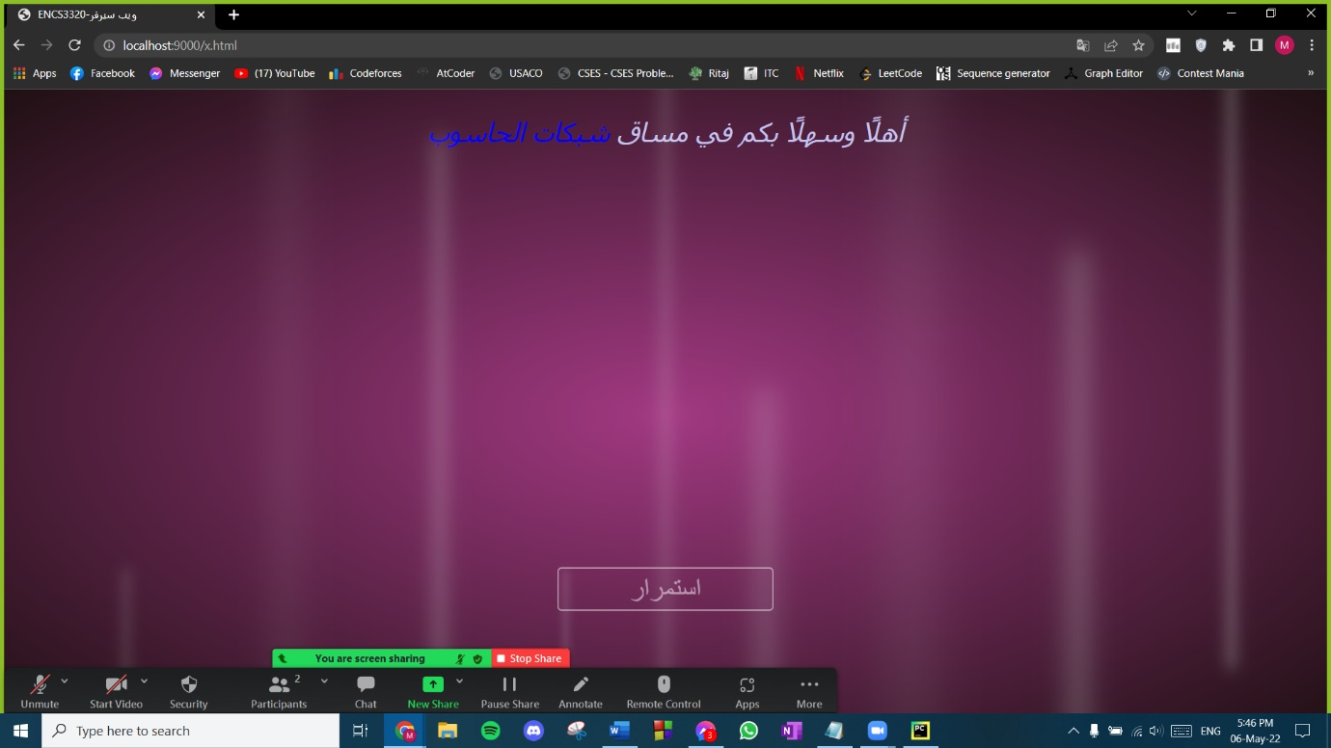

*Figure 20: Response of a .html request*

* 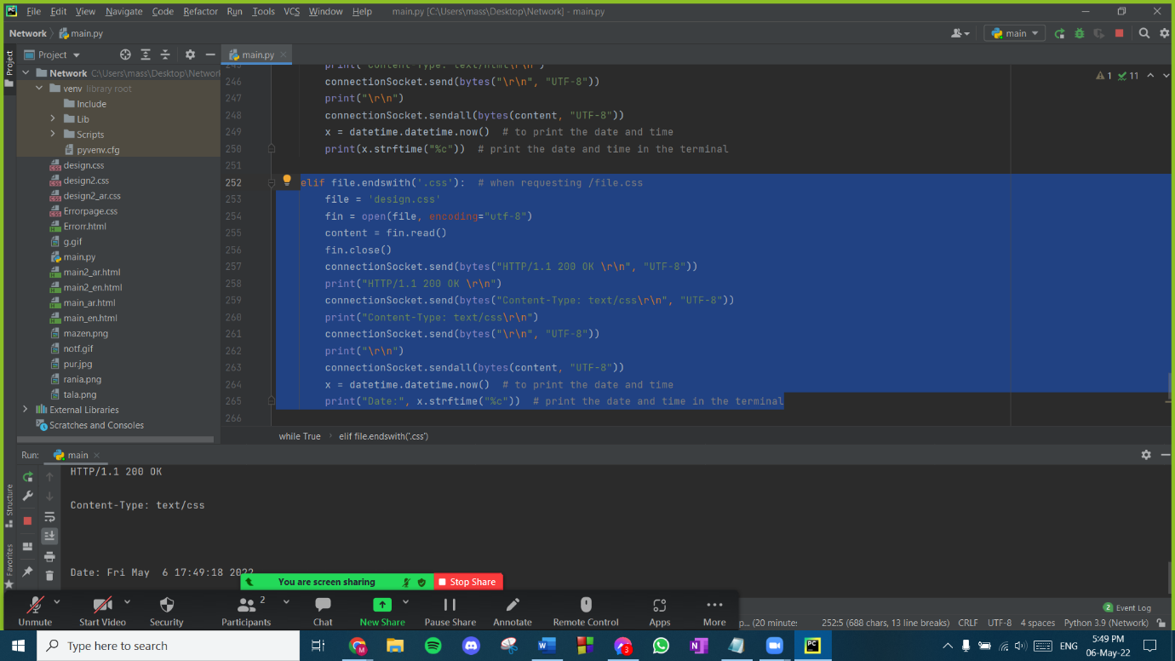Request ends with **.css:**

*Figure 21: A .css request*

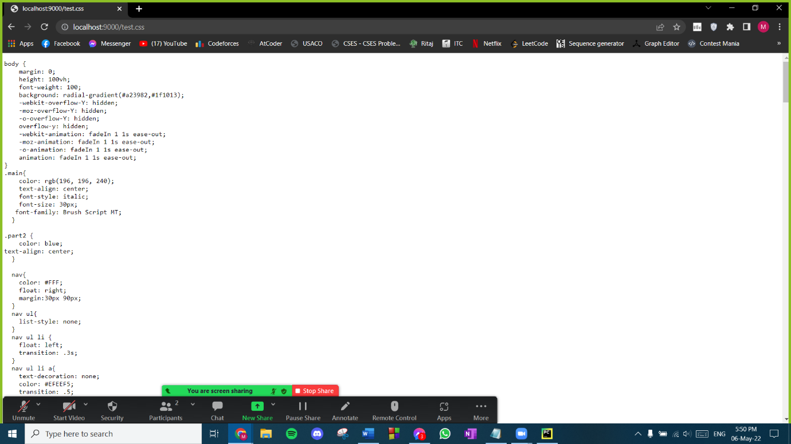

*Figure 22: Response of a .css request*

* 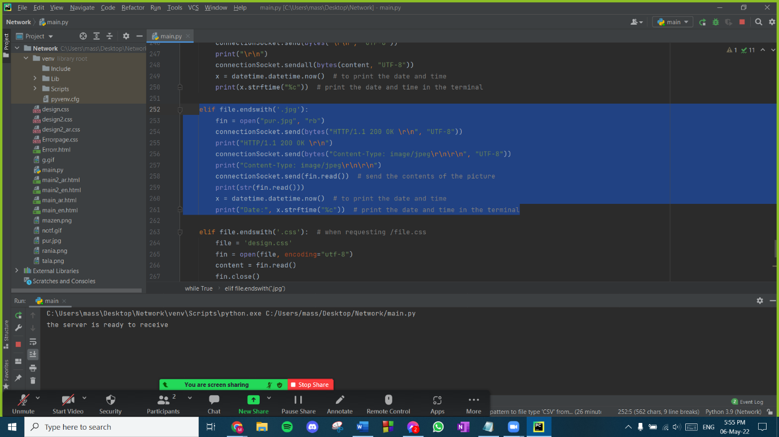JPG request

*Figure 23: A .jpg request*

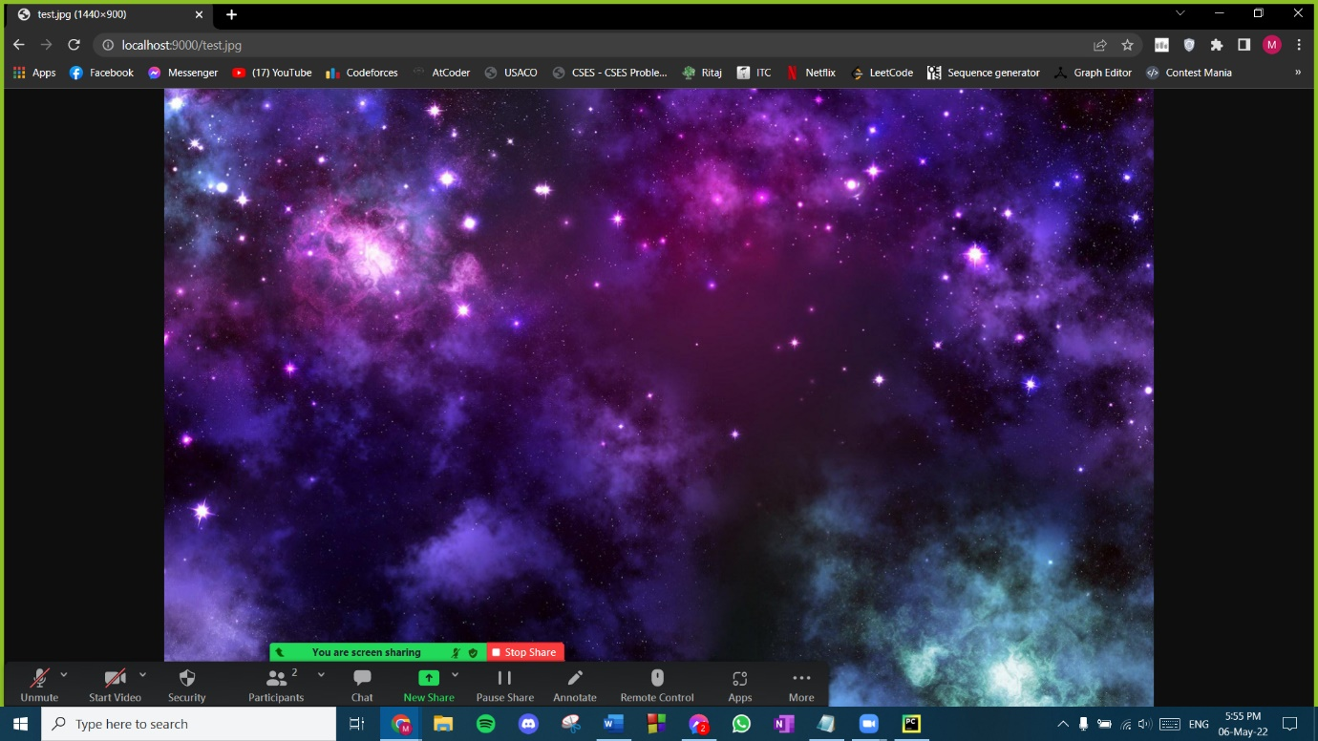

*Figure 24: Response of a .jpg request*

* 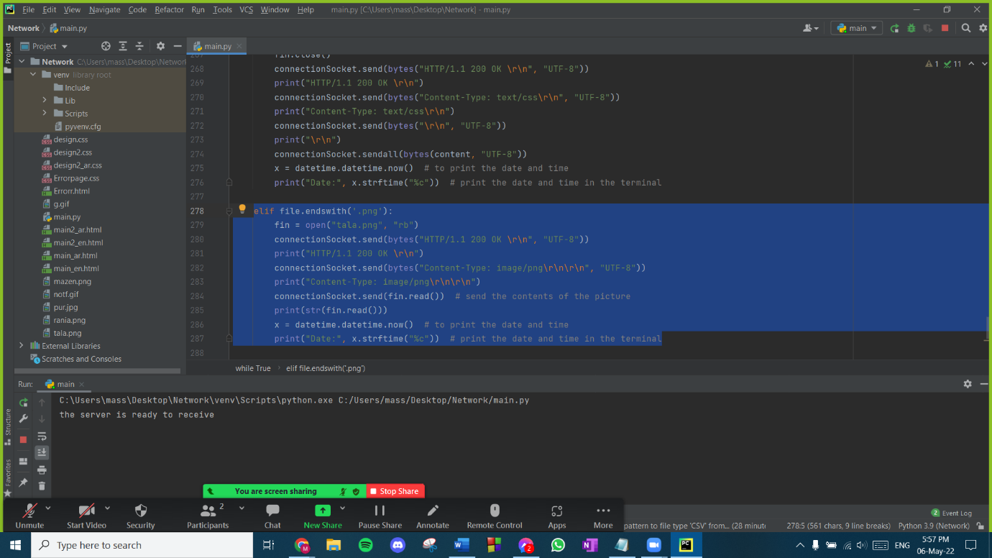Request ends with **PNG**:

*Figure 25: A .png request*

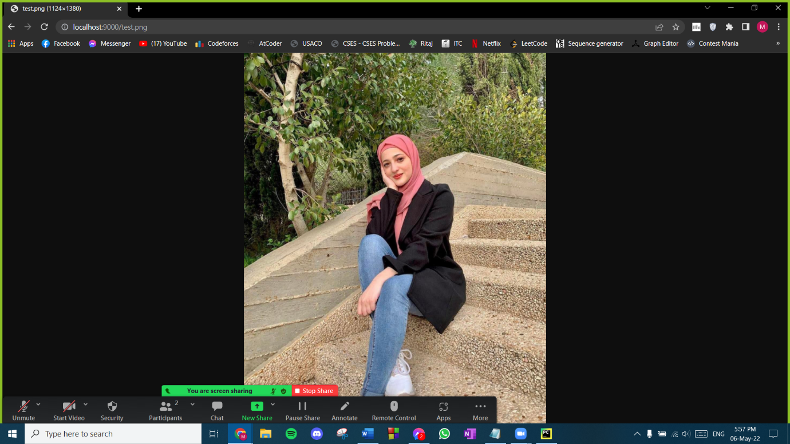

*Figure 26: Response of a .png request*

* 307 Temporary redirect

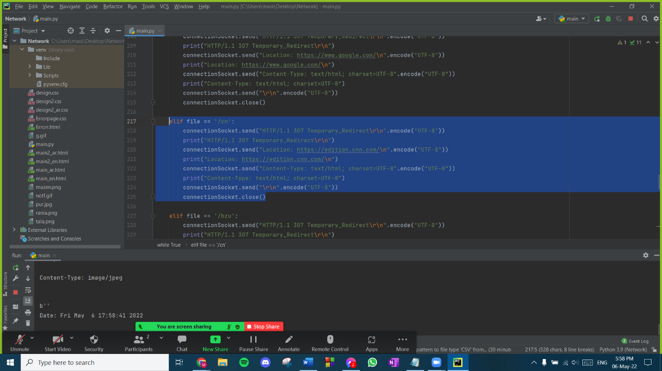We send the server the status 307 and specify the redirect location and the content type as text/html and the encoding. Then, the server redirects to the specified location based on the given request.

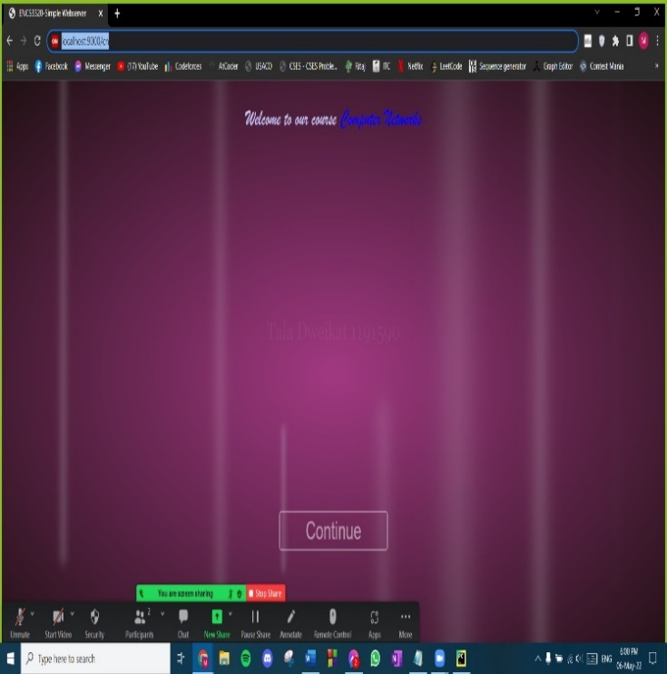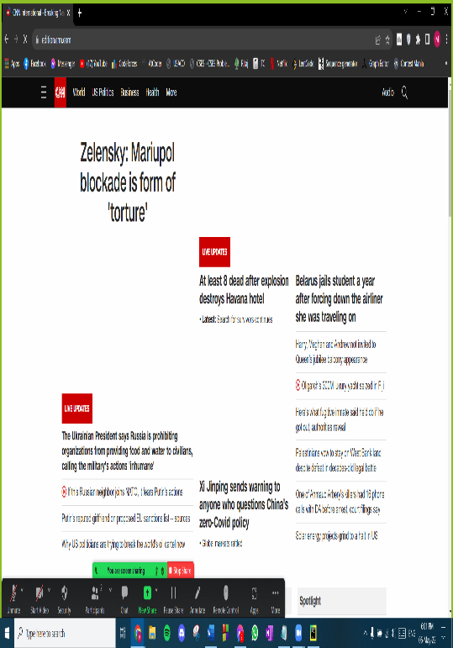  
 *Figure 27: Requests of a 307 temporary redirect to CNN website*

*Figure 28: CNN Redirect*

* Error page

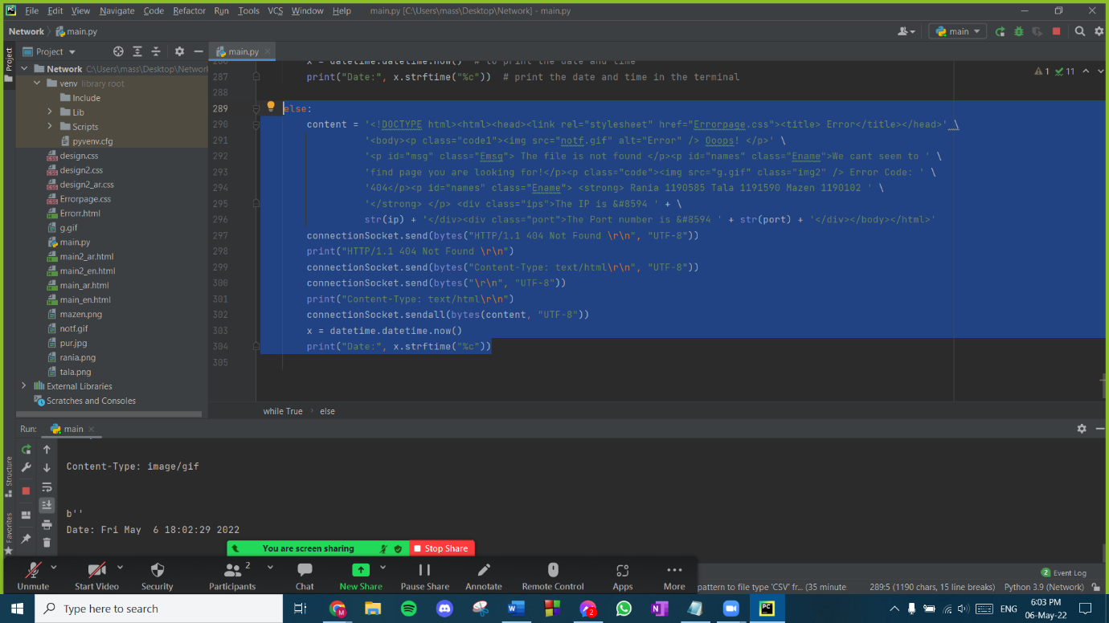If the request is not defined then we redirect to the error page with content type text/html and response status of HTTP/1.1 404 Not Found. It contains the details of the IP and port number of the client. The html code was written in the editor of the python to get the IP and the port.

*Figure 29: code of error page*

* 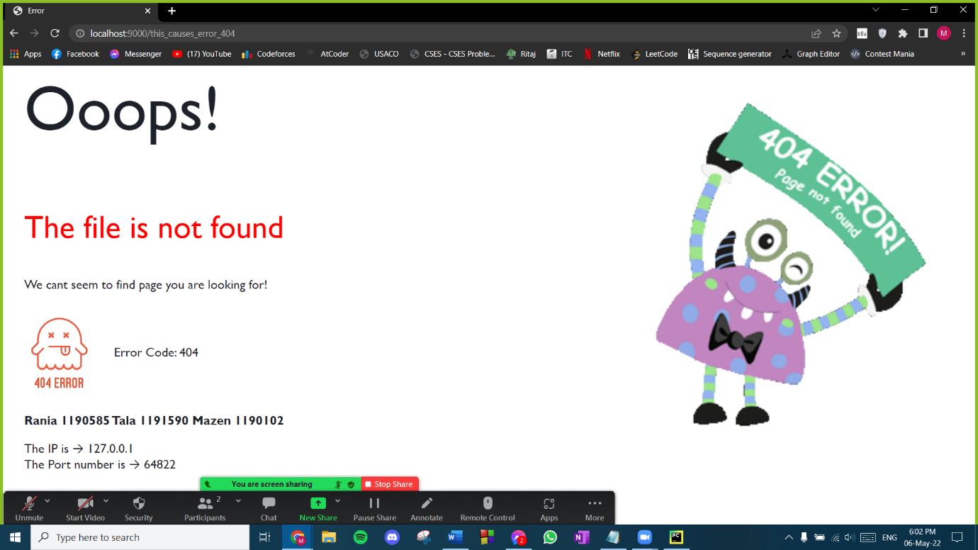Here is the error page:

*Figure 30: Error Page*

As shown in the figures above, a request was sent to **localhost:9000/** The message contents tell that the data was sent to the server using the **GET** method, the HTTP type is **HTTP/1.1**, the content type is specified like text/html, text/css, image/png, etc. The connection type for the request is **persistent** since that was told from the **keep-alive** statement. Similarly, for the other requests, the same operations happen but with different content types and destinations. Here are some requests for CSS files and images. The code and the response of every request was shown.

* Testing from another device
* We tested the project from a phone, everything was going well:

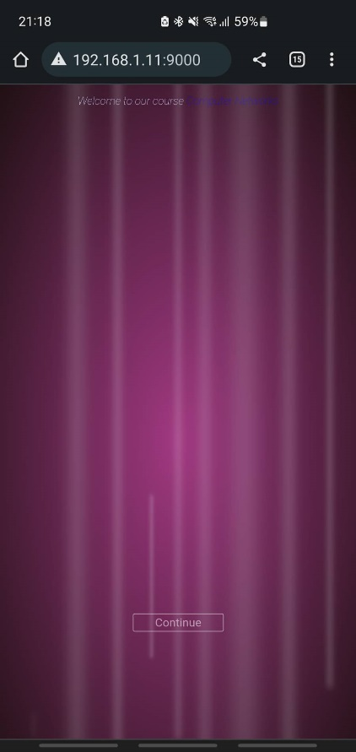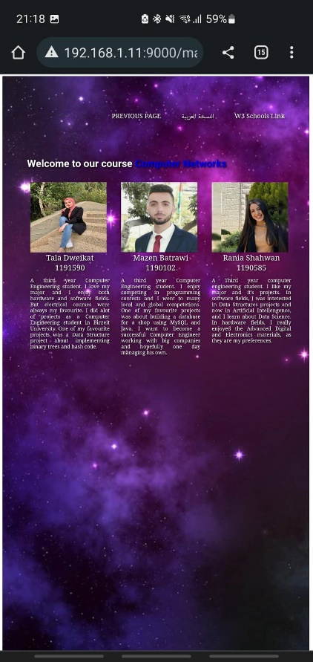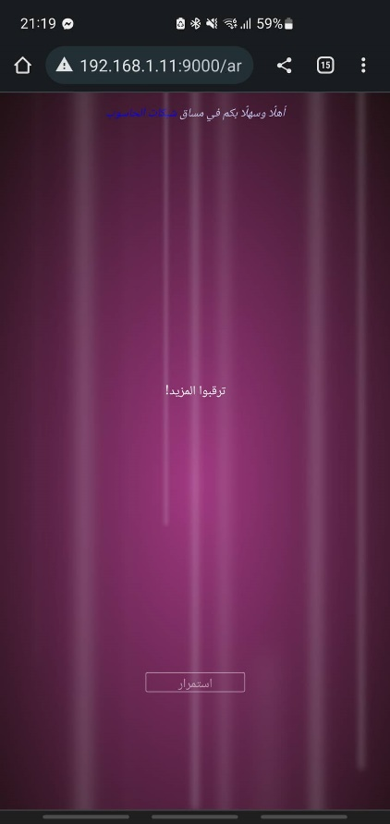

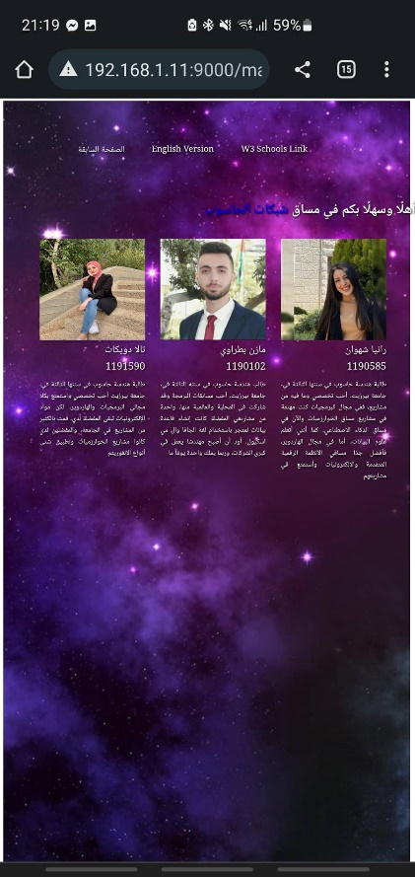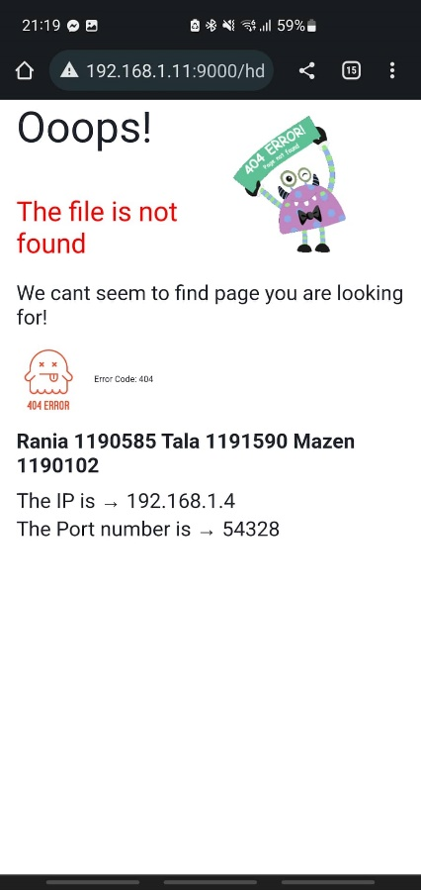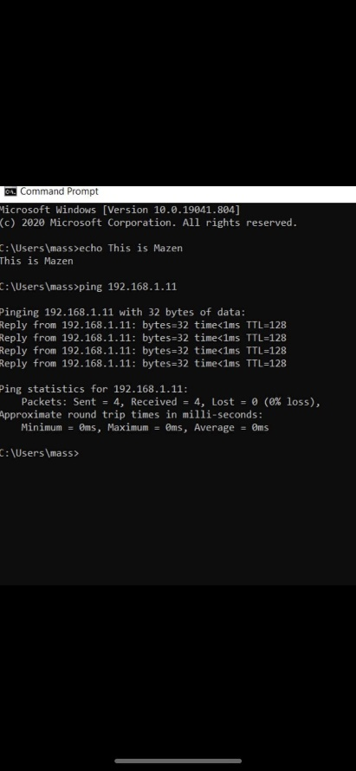

*Figure 31: Testing project from a phone*

* Appendix

